Father Jeremy Sheehy
Chair

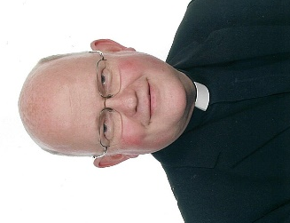
I am Fr Jeremy Sheehy, and I am the rector for the local Church of England parish for Swinton and Pendlebury. I live nearer than anyone else to Chatsworth Futures, in the house which is just opposite the main gate. So I am a governor with local involvement, knowledge, and availability, and hope to offer Chatsworth Futures something because of this. I have served as a governor in a variety of educational settings and am chair of the governors at Saint Peter's School in Swinton - also just opposite Chatsworth Futures. Before coming to Swinton I worked with the training of the clergy in college and many years ago my first degree was in Law."

