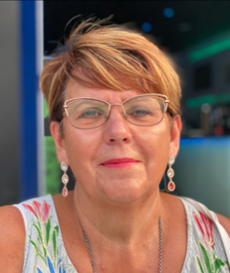
Pat Hodson
Parent/Carer Governor
Pat is fully committed to making a difference in young adult lives. Ensuring that they receive the highest level of support to live a healthy, independent and fulfilling life. Pat has 15 years’ experience working with SEN and looked after people and adults. It is her responsibility to guarantee that people in her care are treated in line with their legal right, and protected from any safeguarding issues.
Pat is delighted to be involved with the Chatsworth Futures Community.

