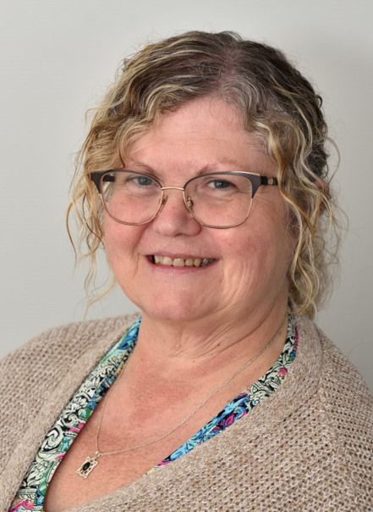
Mandy McMahon
Staff Governor
With over two decades of experience in healthcare and education, I am a dedicated Teaching Assistant passionate about helping learners reach their full potential. Since joining Chatsworth Futures in 2014, I've discovered a love for education and am committed to bringing out the best in every student. My healthcare background includes extensive experience in various specialized roles, including 12 years supporting adults with profound multiple learning disabilities, where I was trained in tracheostomy care, PEG feeding, and epilepsy management. Holding Level 2 & 3 qualifications in Health & Social Care and a Level 3 in Supporting Teaching and Learning, I bring a compassionate, skilled approach to both classroom and individual support, prioritizing the well-being and development of each learner.

